Advantages of design patterns

Design patterns are a form of reusable solutions for a design problem. They are describes as a set of interacting classes that make up a framework for a solution to a design problem in a specific context or field. In object oriented software development design patters suggest a solution to a problem or issue.
Design patterns can save a considerate amount of time and also increase the speed of the development process. Since programming requires the programmer to consider problems or issues that may occur in future implementation, the use of Design patters can help prevent these problems or issues and they can improve code readability.

Currently there are three different type of Design patterns available:

Creational Design Patters
Behavioural Design Patters
Structural Design Patterns

Creational Design Patterns

Creational Design patterns is a design pattern in software engineering that deals with class instantiation and the object creation mechanism, to create objects in an appropriate manner suitable to the situation.
The class creation pattern uses inheritance during the instantiation process and the object creational patter uses inheritance during the delegation process for instantiation.

There are six types of Creational Design Patterns:

Abstract Factory Pattern, Singleton Pattern, Factory Method Pattern, Prototype Pattern, Builder Pattern and Object Pool Pattern.

Behavioural Design Patters

Behavioural Design Patters in software engineering are design patterns that can identify the communication patterns that objects have in common, it then realizes these patterns with the intention of making the interactions between objects easier.

There are ten types of Behavioural Design Patters:
Chain of responsibility, Command Pattern, Interpreter Pattern, Iterator Pattern, Mediator Pattern, Memento Pattern, Observer Pattern, State Pattern, Strategy Pattern and Template Pattern.

Structural Design Pattern

Structural Design Patters is a way to show how different classes or objects can be put together to make a larger structure that can achieve multiple goals altogether. Structural Design Patters demonstrate how unique parts of a system and be put together in a flexible and extensive manner.

There are seven types of Structural Design Patters:

Adapter Pattern, Bridge Pattern, Composite pattern, Decorator Pattern, Facade Pattern, Flyweight Pattern and Proxy Pattern.

Facade Design Pattern

In the Structural Design Pattern list Facade is an interesting pattern. Facade does literally as its name implies, it puts a mask over the complexity of the structure of the system. The structural design pattern Facade offers a simplified and limited interface to a complex system of classes, library or framework by hiding the complexity behind the interface.
Facade can diminish the complexity of the application, it can also helps to put undesired dependencies in one place. Facade has tree layers:
The Presentation layer where the interface is usually placed. The Business layer, where the hard code is usually placed. The Data layer, where the data for the system is stored.
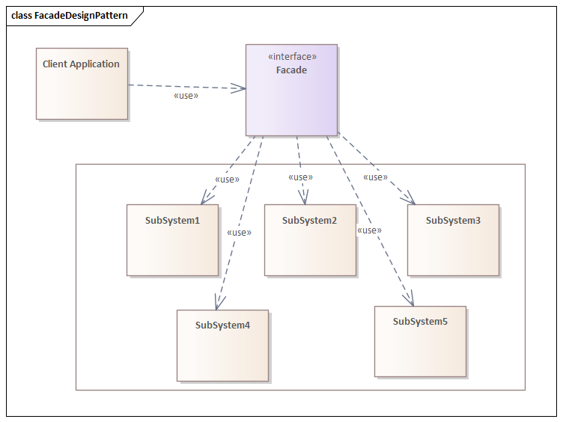

Reference: https://dzone.com/articles/facade-design-pattern-in-java

